**AIM:** Write a Python program to remove and print every second number from a list of numbers until the list becomes empty.

**PROGRAM:**

**def removeThirdNumber(lst):**

**lst1=[]**

**pos=1**

**s=0**

**for i in range(0,len(lst)):**

**s=(pos+s)%len(lst)**

**e1=lst.pop(s)**

**lst1.append(e1)**

**return lst1**

**n=int(input("Enter number of elements:"))**

**int_list=[]**

**for i in range(0,n):**

**e=int(input())**

**int_list.append(e)**

**p=removeThirdNumber(int_list)**

**print(p)**

**LINK:** [**http://103.53.53.18/mod/vpl/view.php?id=231**](http://103.53.53.18/mod/vpl/view.php?id=231)

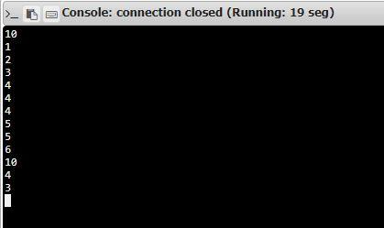**OUTPUT:**

**RESULT:** Thhs the remove the third number program was printed and caluculated